USE CASE DRAMA
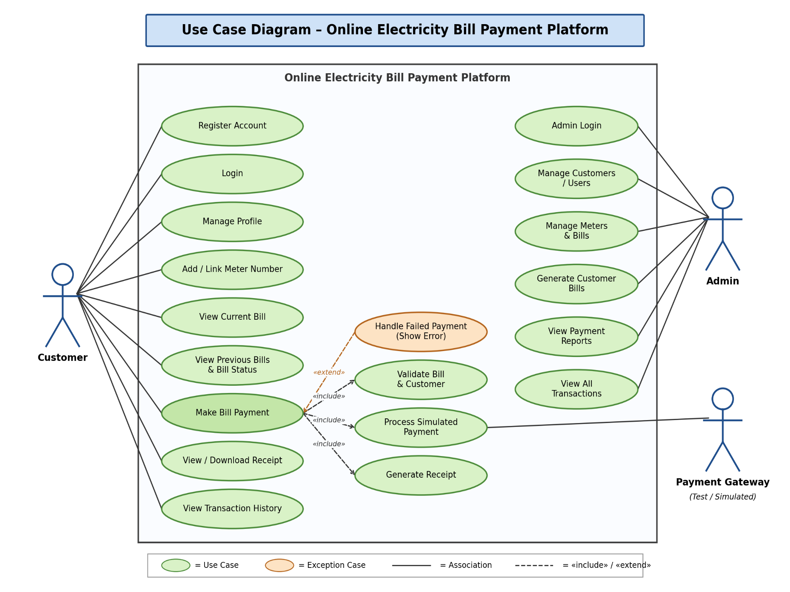
Online Electricity Bill Payment Platform
Use Case Overview
The Use Case Diagram shows the three actors that interact with the Online Electricity Bill Payment Platform and the functions each one can perform.
The Customer can register an account, log in, manage their profile, add or link a meter number, view the current bill, view previous bills and bill status, make a bill payment, view or download a receipt, and view their transaction history.
The Admin can log in, manage customers, manage meters and bills, generate customer bills, view payment reports, and view all transactions.
The Payment Gateway (Test/Simulated) receives the payment request and returns a success or failure response with a transaction ID. No real money moves.
The Make Bill Payment use case includes three steps, which match processes 3.1, 3.2 and 3.4 in the Level 2 DFD:
- Validate Bill & Customer
- Process Simulated Payment
- Generate Receipt
Handle Failed Payment extends Make Bill Payment. It runs only when a payment fails, for example when the simulated gateway declines. This covers the lecturer's requirement to demonstrate both successful and failed operations.All customer use cases except Register Account require the customer to be logged in. All admin use cases require admin login.

